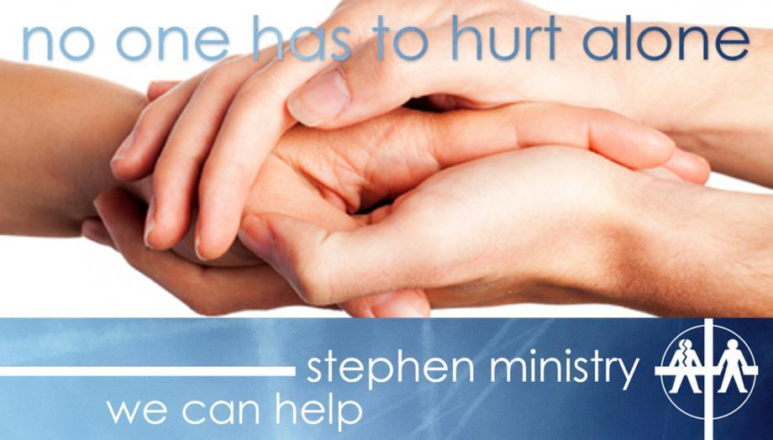

An important theme of the Lenten season is the humanity of Christ. In Jesus, God became human and fully experienced the wide range of emotions we all encounter in life. Jesus experienced times of loneliness, sadness, hurt, anger, disappointment, grief, and abandonment. That is part of being human. Another part of being human is needing help from each other. God never intended us to be completely self-sufficient. Part of God’s plan is for each of us to turn to others for help when we need it.

So when you are experiencing difficult times, don’t struggle alone. Our Stephen Ministers will walk with you, listen to you, encourage you, pray with you, and provide confidential one-to-one care to help you through tough times.

Do you have gifts for caring, encouragement, and listening? If so, please prayerfully consider becoming a Stephen Minister. *Shepherd of the Sea* hopes to train another class of Stephen Ministers this spring. Stephen Ministers provide emotional and spiritual support and care to people who are going through a difficult time, such as divorce, grief, hospitalization, unemployment, terminal illness, relocation, chronic illness, or loneliness.

To find out more about becoming a Stephen Minister or how you or someone you know could be matched with a Stephen Minister, talk with Mandy Bellah or Stephen Ministry Leader at [sosstephenminstry@gmail.com](mailto:sosstephenminstry@gmail.com).  **Our Stephen Ministers are ready to care for you!**

**February 2018 Bulletin Announcements from Stephen Ministry**

Note: Any of these logos would work. Decide which to used based on the space available in the bulletin. 







Feb 4

**Lonely? Experiencing a Difficult Time?**

Don’t suffer alone! Our Stephen Ministers are trained caregivers, ready to listen, care for and encourage you, pray with and for you, and help you through a crisis or difficult time. To find out more, talk with Pastor Brad or Mandy Bellah at stephenministry@shepherdofthesea.com. Our Stephen Ministers are there to care!

Feb 11

For some people, Valentine’s Day is a painful reminder of a broken relationship, the death of a loved one, a recent relocation, a chronic illness, or another life challenge. If you are going through a difficult time, our Stephen Ministers can bring Jesus’ love (God’s ultimate Valentine) back into your life. Stephen Ministers provide confidential, one-to-one Christian care. They will meet with you privately on a weekly basis to listen, to support and encourage you, to pray with and for you, and to walk with you for the duration of your struggle.

To find out more about Stephen Ministry and how you or someone you know could be matched with a Stephen Minister, talk with *Pastor Brad or Mandy Bellah Iat* stephenministry@shepherdofthesea.com*.* Our Stephen Ministers are ready to care for you!

Feb 18

**Are You Stressed? Discouraged? Feeling Down?**

You don’t have to go through difficult times alone. Our Stephen Ministers are ready to provide you with confidential, one-to-one, Christian care and support to help you get through a tough time. So don’t keep it all inside and struggle alone. Our Stephen Ministers are there to care!

To find out more about Stephen Ministry, talk with Pastor Brad or Mandy Bellah at stephenministry@shepherdofthesea.com.

Feb 25

**Stephen Ministers Are There to Care**

Are you going through a difficult time—emotionally, spiritually, or relationally? Are you lonely, experiencing a crisis, or simply stressed by everyday life? You don’t have to suffer alone. Our Stephen Ministers are trained caregivers, ready to listen, care for and encourage you, pray with and for you, and provide confidential one-to-one Christian care to help you through whatever it is that you are facing. To find out more about Stephen Ministry, talk with Pastor Brad or Mandy Bellah at stephenministry@shepherdofthesea.com.